**Create navigation functions**

1. Go to the [Power Apps Studio](https://make.powerapps.com/).
2. Select the **New app** dropdown and choose **Canvas**
3. A new tab will open in your browser. Choose **Tablet layout** under Blank app near the bottom.
4. In the new blank app, select the **Insert** tab, select the **New screen** dropdown, and choose Blank.

[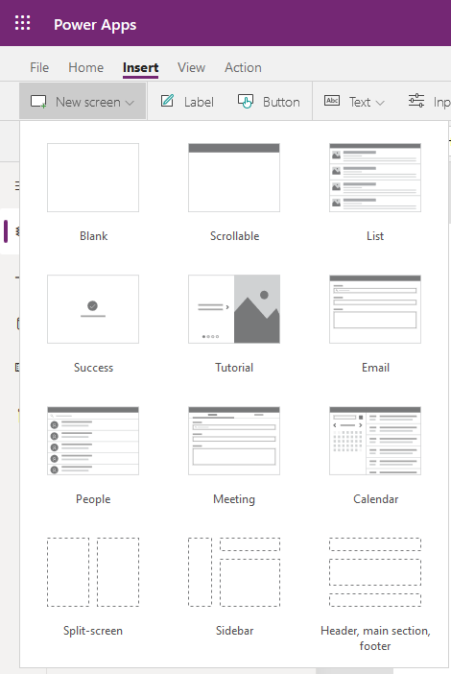](https://docs.microsoft.com/en-us/learn/modules/navigation-canvas-app/media/new-screen-ss.png#lightbox)

1. This will create a new blank screen in your app. Repeat once more to have three screens total.
2. On Screen1, insert a **Button** control and change the **Text** property to **Next**.
3. On Screen2, add a **Button** control and change the **Text** to **Next**.
4. Add another **Button** control and change the **Text** to **Back**.
5. On Screen3, add a **Button** control and change the **Text** property to **Back**.
6. On Screen1, set the Next button **OnSelect** property to **Navigate(Screen2,ScreenTransition.Fade)**.

[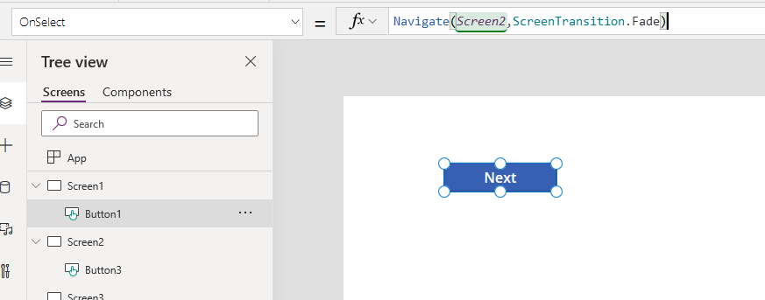](https://docs.microsoft.com/en-us/learn/modules/navigation-canvas-app/media/next-button-ss.png#lightbox)

1. On Screen2, set the **OnSelect** property for the Next button to **Navigate(Screen3,ScreenTransition.Cover)**.
2. Set the **OnSelect** property for the Back button to **Back().**

[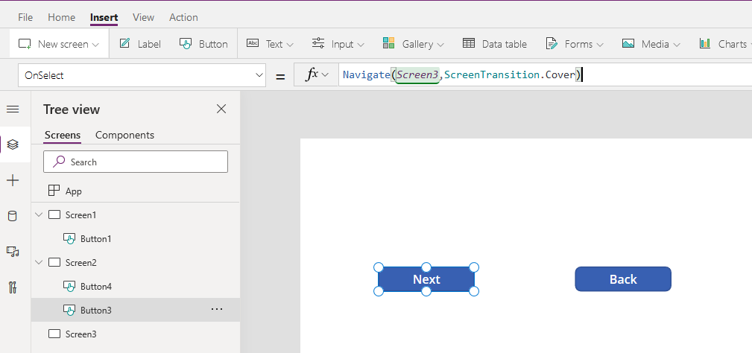](https://docs.microsoft.com/en-us/learn/modules/navigation-canvas-app/media/next-screen-2-ss.png#lightbox)

1. On Screen3, set the **OnSelect** property for the Back button to **Back()**.

[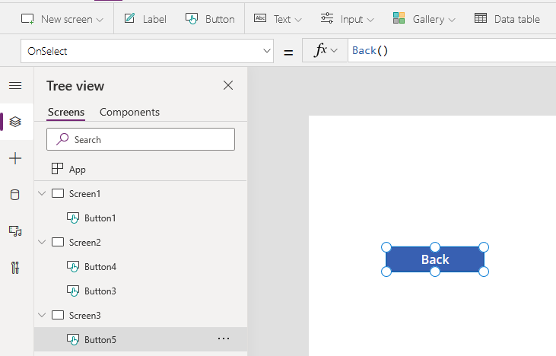](https://docs.microsoft.com/en-us/learn/modules/navigation-canvas-app/media/back-ss.png#lightbox)

1. To test this, put the app in Preview or Play mode and navigate through the app as a user would.